ARAŞTIRMA MAKALESİ

NEW APPROXIMATIONS WITH DIFFERENT TYPE NEURAL NETWORK STRUCTURES AND ALGORITHMS FOR PERFORMANCE INCREMENT OF AC DRIVE CONTROL SYSTEMS

Kayhan GÜLEZ

Yıldız Technical University, Electrical-Electronics Faculty, Electrical Engineering Department,
Yıldız-İSTANBUL

Geliş Tarihi: 10.01.2003

AC SÜRME DEVRELERİNE SAHİP KONTROL SİSTEMLERİNDE PERFORMANS ARTTIRIMI İÇİN FARKLI TİP SİNİR AĞI YAPILARI VE ALGORİTMALARI İLE YENİ YAKLAŞIMLAR

ÖZET

Bu makalede, DSP tabanlı bir kontrol biriminin, AC sürme devresine sahip motor kontrol sistemlerine performans arttırımı icin uygulanmasinda farkli tip sinir agları ile yaklaşımlar temel ve önemli bir çalışma olarak dikkate alınmıştır. Burada Fast Back-propagation algoritması motor kontrol uygulamalarına ve AC sürme deverelerine ilk kez uygulanmaktadır. Algoritma, sistem hatasını azaltmada ve çok yüksek işleme hızını sağlamada eş zamanlı olarak oldukça başarılı sonuçlar vermektedir.

ABSTRACT

In this paper, the new approximations with different type neural networks for the application of AC drive motor control systems to increase the performance using a DSP based control according to variable load conditions, as a basic and important study is considered. Fast Back-propagation algorithm is firstly used for motor control applications and AC Drives through the paper. The algorithm gives considerably important success to decrease the system error and ensure very high data processing time simultaneously.

1. INTRODUCTION

In recent years, control systems have assumed an increasingly important in the development and advancement of modern civilization and technology. One of the major problems of motor drives is that they are traditionally designed with relatively inexpensive analogue components. The weaknesses of analogue systems are their susceptibility to temperature variations and the component aging. Another difficulty is upgrading the system for new needs [1]-[8]. The usage of changeable load conditions affects the performance of AC drives-especially induction motor control systems directly. In recent years, all new type control methods are being designed to improve digital control structures. Digital control structures eliminates drifts, solve complex mathematical equations and by using programmable processor it can be easily upgraded for new control algorithms. Digital Signal Processors (DSP) go further; their high performance allows them to perform high resolution control and minimise control loop delays. By the help of their fast processor which works parallel, many complicated control algorithms can be implemented easily [4], [6], [8]. With the importance of digital control structures, it was used a TMS320C50 processor board to implement the dynamic speed controller to induction motor. New technologies such as neural networks, fuzzy logic etc., give the opportunity to upgrade, update and improve the system according to new needs easily and accurately.
The basic ingredients of a control system can be described by objectives of control system components and results or outputs. In block diagram form, the basic relationship between these components is illustrated in Figure 1 [8].
K. Gülez YTÜD 2003/3
Almost, every control system includes a servo motor with a soft feed back. They need good results to implement to system. Thus, it is designed a dynamic speed controller (including PI structure) to use the main advantages of robust structure of induction motor under the control of a DSP-based system.
Control
System
Objectives
Output
(Results)

Figure 1. Basic components of a control system

Field Oriented Control (FOC) method including PI parameter adaptation is used for the control structure of DSP implementation. FOC is based on three major points: the machine current and voltage space vectors, the transformation of a three phase speed and time dependent system into a two co-ordinate time invariant system and effective Pulse With Modulation (PWM) pattern generation. Thanks to these factors, the control of AC machines acquires every advantage of DC machine control and frees itself from the mechanical commutation drawbacks. Furthermore, this control structure, by achieving a very accurate steady state and transient control, leads to high dynamic performance in terms of response times and power conversion.
FOC consists of controlling the stator currents represented by a vector [3]. This control is based on projections which transform a three-phase time and speed dependent system into a two co-ordinate (d and q co-ordinates) time invariant system. These projections lead to a structure similar to that of a DC machine control. As FOC is simply based on projections the control accurate in every working operation (steady state and transient) and independent of the limited bandwidth mathematical model. The FOC thus solves the classic scheme problems, in the following ways,
- the ease of reaching constant reference (torque component and flux component of the stator current)
- the ease of applying direct torque control because of the expression of the torque in the (d, q) reference frame.
By maintaining the amplitude of the rotor flux at a fixed value we have a linear relationship between torque and torque component. The torque can then be controlled by controlling the torque component of stator current vector by using Clark and Park transforms [15].

2. THE MATHEMATICAL STRUCTURE OF INDUCTION MOTOR AND DYNAMIC SPEED CONTROLLER

Following equations show the induction motor mathematical model and PI controller [10], [12], [15].
$\overset{→}{v_{s}}=R_{s}\overset{}{{\overset{→}{i}}_{s}+L_{s}\frac{d\overset{→}{i_{s}}}{\text{dt}}+L_{m}\frac{d}{\text{dt}}(\overset{→}{i_{r}}e^{{jθ}_{r}}})$ (1)
$0=R_{r}\overset{→}{i_{r}}+L_{r}\frac{d\overset{→}{i_{r}}}{\text{dt}}+L_{m}\frac{d}{\text{dt}}(\overset{→}{i_{s}}e^{−{jθ}_{r}})$ (2)
$\begin{aligned}J\frac{{\text{dw}}_{r}}{\text{dt}}+{\text{Bw}}_{r}=T_{e}−T_{d} \\ \frac{P}{2}L_{m}I_{m}\left[\overset{→}{i_{s}}(\overset{→}{i_{r}}e^{{jθ}_{r}})^{}\right]−T_{d}\end{aligned}$ * represents a matrix vector. (3)
New Approximations with Different Type…
$\frac{{dθ}_{r}}{\text{dt}}=w_{r}$ (4)
Thus, the torque equation can be shown as,
$T_{e}=\frac{P}{2}\frac{L_{m}}{L_{r}}(i_{\text{sq}}ψ_{\text{rd}}−i_{\text{sd}}ψ_{\text{rq}})$. (5)
After some mathematical computations, the following equation is obtained.
$T_{e}=\frac{P}{2}\frac{L_{m}}{L_{r}}ψ_{r}i_{\text{sq}}$ (6)
$T_{e}^{}=K_{t}i_{\text{sq}}^{}$ (7)

${\frac{w_{m}(s)}{w_{m}^{}(s)}}_{T_{d}=0}=\frac{K_{i}K_{t}}{{\text{Js}}^{2}+(B+K_{p}K_{t})s+K_{i}K_{t}}$ (8)
comparing with a second order system, damping factor and natural frequency,
$ξ=\frac{B+K_{p}K_{t}}{2({\text{JK}}_{i}K_{t})^{1/2}} ; w_{d}=(\frac{K_{i}K_{t}}{J})^{1/2}$ (9)
and bandwidth is
$\text{BW}=w_{d}\sqrt{1−2ξ^{2}+(2−4ξ^{2}+4ξ^{4})^{1/2}}$ (10)
related to response time for equation 8,
$t_{c}≈\frac{3\text{.}\text{875}}{w_{d}}≈\frac{0\text{.}\text{65}×3\text{.}\text{875}}{\text{BW}} ξ=1 \text{for}$ (11)
$K_{i}={{\text{Jw}}_{d}^{2}}/{K_{t}} ; K_{p}=(2{\text{Jw}}_{d}−B)/{K_{t}}$ (12)
The PI controller block diagram is depicted in Figure 2. Table 1 shows the parameters of the tested motor.

3. ARTIFICIAL NEURAL NETWORKS (ANN)

Artificial Neural Networks (ANN) are successfully used in a lot of areas such as control, early detection of electric machine faults, digital signal processing in our daily technology [12]-[13]. The feed-forward neural network is usually trained by a back-propagation training algorithm first proposed by Rumelhart, Hinton, and Williams in 1986. This was the effective usage of it only after 1980s. With the help of speedy computers, NNs are more realistic and easily updateable today. The distributed weights in the network contribute to the distributed intelligence or associative memory property of the network. With the network initially untrained, i.e., with the weights selected at random, the output signal pattern will totally mismatch the desired output
K. Gülez YTÜD 2003/3
T_{d}

w*_{m}
w_{m}

w_{m}
K_{t}
K_{p}
i*_{sq}
T*_{e}
+
-
+
+
-
+
Figure 2. The block diagram of PI controller

Table 1. The parameters of the tested motor
Power rating | 0.56 kW
Rated voltage | 380 V
Pole pairs | 2
Total inertia (J) | 2.33 g-m²
R_{s} | 0.17 Ω
R_{r} | 0.33 Ω
L_{s} | 31.4 mH
L_{r} | 33.4 mH
L_{m} | 3.18 mH

pattern for a given input pattern. The actual output pattern is compared with the desired output pattern and the weights are adjusted by the supervised back-propagation training algorithm until the pattern matching occurs, i.e., the pattern errors become acceptably small.

3.1. Classic Back-propagation Algorithm

Following equations show the basic ones of classic error back-propagation algorithm [12],[13].
$o_{j}=f({\text{net}}_{j})=f(x) \text{ise} {\text{net}}_{j}=\sum_{j}^{i}{w_{\text{ji}}o_{i}+θ_{j}}$ (13)
$E_{p}=\frac{1}{2}\sum_{j∈\text{output}}{(t_{\text{pj}}−o_{\text{pj}})}$ (14)
$\begin{aligned}δ_{\text{pj}}=(t_{\text{pj}}−o_{\text{pj}}) \\ Δ_{p}w_{\text{ji}}=−ε(\frac{∂E_{p}}{∂w_{\text{ji}}}) \\ Δ_{p}θ_{j}=−ε(\frac{∂E_{p}}{∂θ_{j}}) \end{aligned}$ (15)
New Approximations with Different Type…
If it is used "sigmoid" function, as the transfer (threshold) one in the operation element;
$o_{\text{pj}}=\frac{1}{\sum_{i}{1+e^{−w_{\text{ji}}o_{\text{pi}}+θ_{j}}}}$ (16)
it is derived the equation 16 and done necessary shortening;
$\frac{∂o_{\text{pj}}}{∂{\text{netp}}_{j}}=o_{\text{pj}}(1−o_{\text{pj}})$ (17)
If this is replaced in equation 16, for output element;
$δ_{\text{pj}}=(t_{\text{pj}}−o_{\text{pj}})o_{\text{pj}}(1−o_{\text{pj}})$ (18)
for hidden layer element;
$δ_{\text{pj}}=o_{\text{pj}}(1−o_{\text{pj}})\sum_{k}{δ_{\text{pk}}w_{\text{kj}}}$ (19)
If it is added (α ) momentum term to the general equation set to speed up the computation of the algorithm, in the most general condition, it is given output and hidden layer equations as follows:
$\begin{aligned}Δ_{p}w_{\text{ji}}(t+1)={\text{εδ}}_{\text{pj}}o_{\text{pi}}+{αΔ}_{p}w_{\text{ji}}(t) \\ Δ_{p}θ_{j}(t+1)={\text{εδ}}_{\text{pj}}+{αΔ}_{p}θ_{j}(t)\end{aligned}$ (20)
Here; t: the number of learning cycles.
(α ): a small positive number.

3.2. Fast Back-propagation Algorithm

The fast version [14], of the back-propagation algorithm is derived by sequentially minimizing the objective function G_{k} (λ), defined by equation 21, for k=1,2,.....m. The update equation for the synaptic weights w_{pq} is obtained as equation 22.
$G_{k}(λ) = λ\sum_{i=1}^{n_{0}}{φ_{2}(e_{i,k}) + (1−λ)\sum_{i=1}^{n_{0}}{φ_{1}(e_{i,k}) ∀ k=1,2,\text{.}\text{.}\text{.}\text{.}\text{.}\text{.},m}}$ (21)
$w_{p,k} = w_{p,k−1} + {\text{αε}}_{p,k}^{0}(λ){\overset{}{h}}_{k}$ (22)
If the output of the network is analog,
$ε_{p,k}^{0}(λ) = λ(y_{p,k}−{\overset{}{y}}_{p,k}) + (1−λ)\text{tanh}\left[β(y_{p,k}−{\overset{}{y}}_{p,k})\right]$ (23)
K. Gülez YTÜD 2003/3
On the other hand, if the network has binary outputs,
$ε_{p,k}^{0}(λ) = (1−{\overset{}{y}}_{p,k}^{2})(y_{p,k}−λ{\overset{}{y}}_{p,k})$ (24)
Because of its simplicity and fast, this algorithm provides an ideal basis for investigating the role of λ during training. Here, ε_{p,k} and α are the output error and learning rate respectively. λ is given as,
λ=exp(-μ/E²) (25)
where μ is selected by user. μ is error decreasing sub-coefficient.

4. NEURAL NETWORK STRUCTURES FOR PERFORMANCE INCREMENT

4.1. Standard Order- Classic Back-propagation Algorithm Structure

For all the applications [9], [10], [11], It was used 0.55 kW, 2.6A, 220V, 50Hz, Cosφ=0.79 3-phase squirral-cage induction motor. The processsor used in this work is, 40Mhz TMS320C50 DSP with 10k x 16 words of on-chip RAM which works parallel with TLC320C40 Analogue interface circuitry (AIC) with 14 bit. The processor is communicated with a PC through RS232 serial port [15]. The other motor coupled to the induction motor is a DC motor to work as generator to give the changeable load. The DC motor is 150-300V, 8.5-8.5A, 1-2 kW, 1500-3000 rpm, U_{Err}=220V, I_{Err}=0.6A including a digital tachometer. It is driven by a oto-transformer which has 220V/50 Hz AC input over a diode bridge, 385V/470μF capacitor and 2A circuit breaker. It was also used 2 Escor Pro5 5A Hall Effect sensors to sense the phase currents and 3 measurement circuits (mainly including LM741 operational amplificators) for comparative conditions of voltage levels especially for DSP inputs. DM7404 Hex Inverter was used for a time delay because of only one ADC-DAC unit. The signals were given over 74AHC573 Latch [15], and CD4016C to the control loop. Firstly, it was taken the numerical values belonging to the variables of the motor used in the training of neural network structure with the help of DSP based system. It was to say to run the control algorithm. The equations of the induction motor used in the application has been the tunable control algorithm of the DSP based system.
The language of ANN and Digital Signal Processor are C++ and Assembler respectively. In this application, for Classic Back-propagation Algorithm, as the input values to ANN, rotor speed (n) as angular speed (w), current (I) and power (P), as the output value to it torque (T) of the motor to increase the performance of the system are made and discriminated with success rate %0.0011 for 300000 iterations. There are 3 hidden layers including 5, 4, and 3 nodes in each one respectively. Table 2 and 3 show the full set of measurements result values of the system and test phase results respectively. It is depicted test phase results diagram in Figure 3.

4.2. Standard Order- Fast Back-propagation Algorithm Structure

In this application, for Fast Back-propagation Algorithm, as the input values to ANN, rotor speed (n) as angular speed (w), current (I) and power (P), as the output value to it torque (T) of the motor to increase the performance of the system are made and discriminated with success rate %0.0007 for 300000 iterations. Also, there are 3 hidden layers including 5, 4, and 3 nodes in each one respectively. Table 4 shows test phase results. It is depicted in Figure 4, test phase results comparative diagram.

w (rpm)I (A)P (%)T (%)000010.47192.5060.0005710.02564.92621.4910.04060.187585.87011.4320.07140.25121.47490.8350.14950.3625142.41880.7750.22130.4375178.02350.6510.3270.5375194.77870.5370.3890.5875222.00580.4120.49670.6625289.02650.2810.85420.875301.59280.2800.93340.9286.93210.2820.86530.9247.13860.2920.62170.7375209.43950.4160.44150.625182.21230.5980.3390.55136.13560.7820.18360.469.11501.5530.04690.214.66072.4460.002410.05

Table 2. Some numerical values of the training set for all applications
New Approximations with Different Type…

w (rpm)I (A)P (%)T (%)ANN Results
T (%)43.98221.8600.020530.1250.132078127.75810.8310.1650.38750.379243207.34510.4170.44560.6250.627734278.55450.2830.7920.83750.841526194.77870.5370.38950.58750.587541100.53091.3060.009460.30.29256820.94391.8470.004120.06250.060119

Table 3. Test phase results for for Standard Order- Classic Back-propagation Algorithm Structure

Figure 3. Test phase results comparative diagram with measurements for Standard Order- Classic Back-propagation Algorithm Structure

K. Gülez YTÜD 2003/3

w (rpm)I (A)P (%)T (%)ANN Results
T (%)43.98221.8600.020530.1250.127778127.75810.8310.1650.38750.385945207.34510.4170.44560.6250.626175278.55450.2830.7920.83750.838156194.77870.5370.38950.58750.587261100.53091.3060.009460.30.29958820.94391.8470.004120.06250.061510

Table 4. Test phase results for Standard Order- Fast Back-propagation Algorithm Structure

Figure 4. Test phase results comparative diagram with measurements for Standard Order- Fast Back-propagation Algorithm Structure

New Approximations with Different Type…

Figure 5. Test phase results comparative diagram with measurements for High Order- Classic Back-propagation Algorithm Structure

Figure 6. Test phase results comparative diagram with measurements for High Order- Fast Back-propagation Algorithm Structure

K. Gülez YTÜD 2003/3

I
w
P

I*w
I²
w²
P²

Figure 7. The ANN architecture of the system to increase the performance

T
H.L.1-5, H.L.2-4, H.L.3-3

4.3. High Order- Classic Back-propagation Algorithm Structure

In this application part, for Classic Back-propagation Algorithm, as the input values to ANN rotor speed (n) as angular speed (w), current (I), power (P), square of w, I, P and multiply of w and I, as the output value to it torque (T) of the motor with the same hidden layer structure such as previous ones to increase the performance of the system are made and discriminated with success rate, %0.0009 for 300000 iterations. Table 5 shows test phase results. It is depicted in Figure 5, test phase results comparative diagram.

4.4. High Order- Fast Back-propagation Algorithm Structure

In this application part, for Fast Back-propagation Algorithm, as the input values to ANN rotor speed (n) as angular speed (w), current (I), power (P), square of w, I, P and multiply of w and I, as the output value to it torque (T) of the motor with the same hidden layer structure such as previous ones to increase the performance of the system are made and discriminated with success rate, %0.0004 for 300000 iterations. Table 6 shows test phase results. It is depicted in Figure 6 and 7, test phase results comparative diagram and ANN structures for these all applications. Figure 8 and 9-12 show the whole control system and the different perspective photos of the experimental set.
New Approximations with Different Type…
w (rpm)I (A)P (%)w²43.98221.8600.020531934.43127.7580.8310.16516322.1207.3450.4170.445642991.9278.5540.2830.79277592.6194.7780.5370.389537938.7100.5301.3060.0094610106.420.94391.8470.00412438.64I²w*IP²T (%)ANN Resl.
T (%)3.4596692.30.000420.1250.130170.69011270.40.027220.38750.381240.1737472.00.198550.6250.625530.0806213.60.627260.83750.839260.28810937.70.151710.58750.587441.70517237.50.008940.30.294673.4111496.30.000010.06250.06225

Table 5. Test phase results for High Order- Classic Back-propagation Algorithm Structure

w (rpm)I (A)P (%)w²43.98221.8600.020531934.43127.7580.8310.16516322.1207.3450.4170.445642991.9278.5540.2830.79277592.6194.7780.5370.389537938.7100.5301.3060.0094610106.420.94391.8470.00412438.64I²w*IP²T (%)ANN Resl.
T (%)3.4596692.30.000420.1250.124420.69011270.40.027220.38750.388850.1737472.00.198550.6250.624010.0806213.60.627260.83750.836880.28810937.70.151710.58750.587481.70517237.50.008940.30.301653.4111496.30.000010.06250.06311

Table 6. Test phase results for High Order- Fast Back-propagation Algorithm Structure
K. Gülez YTÜD 2003/3

5. CONCLUSIONS

It is considerably important success to access this performance increment as a basic study for further approximations of the subject, that is, under changing the value of the load, the load-torque rises to the same value performance in a very short time (mili seconds degree for CBA and nano seconds degree FBA). In the application of Standard Order-Classic Back-propagation Algorithm structure, as the input values to ANN, rotor speed (n) as angular speed (w), current (I) and power (P), as the output value to it torque (T) of the motor to increase the performance of the system are made and discriminated with very low error rate %0.0011 for 300000 iterations. These results are %0.0007 for 300000 iterations for Standard Order-Fast Back-propagation Algorithm structure, %0.0009 for 300000 iterations for High Order-Classic Back-propagation Algorithm structure and %0.0004 for 300000 iterations for High Order-Fast Back-propagation Algorithm structure. The results of the last one (High Order-Fast Back-propagation Algorithm Structure) are better than the others in case of the error ones.

New Approximations with Different Type…

T
(N, B)
Figure 8. The block diagram of DSP- based control system including ANN controller

TMS320C50
DSP

INVERTER

NN
Controller
1

COMPUTER
OTO
TRANS
FORMER
ENCODER
LATCH
AMP. 1

RESISTANCE
GROUP

INDUCTION
MOTOR

DC
MOTOR

I, w, P
(I², w², I*w, (s), P²)
T.G.
ANN Controller for The Switching Modes of The Inverter-2
AMP. 2
DAC

AIC

ADC

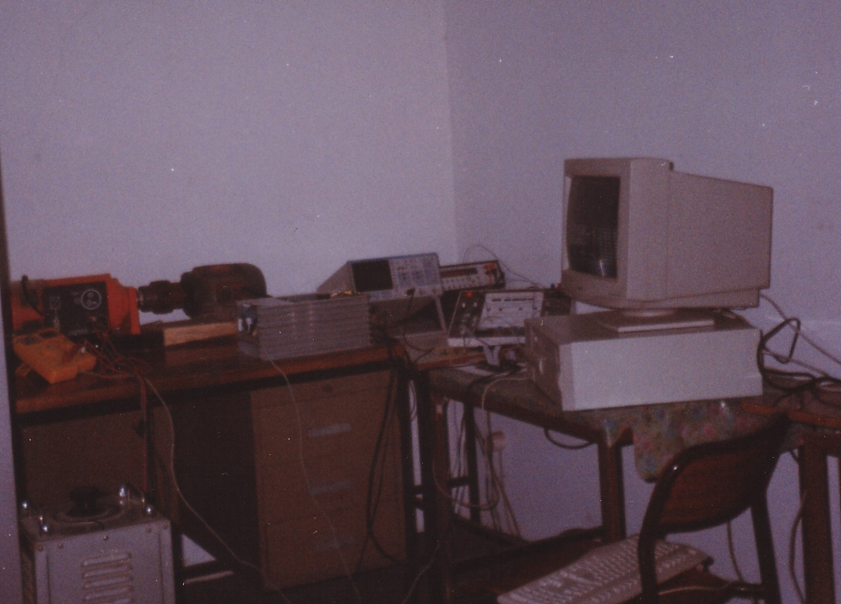
Computer
Including Necessary Software
DC Motor
Oto-
Transformer
Inverter
AC Induction Motor
Amplificator-2

Amplificator-1
LATCH
TMS320C50-DSP
Figure 9. The photo of whole real-time induction motor control system for the standard 6-IGBT inverter

K. Gülez YTÜD 2003/3

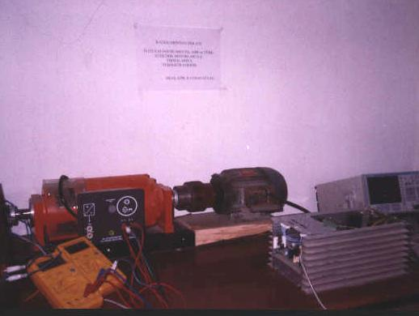
DC Motor
Measurement Tools to check Voltage, Current and Torque

Inverter
AC Induction Motor
High Resolution Scope

Figure 10. The photo of only real-time induction motor control system part

Amplificator-1
Amplificator-2
LATCH

High Resolution Scope

TMS320C50-DSP

Inverter
Computer
Including Necessary Software

Figure 11. The photo of DSP (Digital Signal Processor) and amplificators part of the system

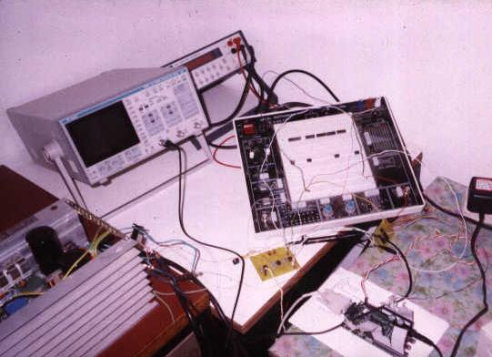

High Resolution Scope

TMS320C50-DSP

Inverter
Computer
Including Necessary Software

Figure 12. The photo of DSP and computational part of the system

Amplificator-1
Amplificator-2
LATCH

New Approximations with Different Type…

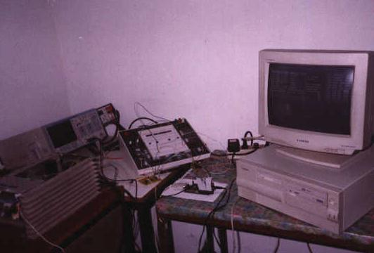

ACKNOWLEDGMENTS

This study was supported TI Europe Branch, ABB Turkish Branch and Turkish Electrical Motors A.S. as equipment and technical document. Thus, special thank to TI Europe Branch, ABB Turkish Branch and Turkish Electrical Motors A.S.

REFERENCES

[1] Boldea, I. Ve Nasar, S.A., “Vector Control of AC Drives, CRC Press”, 1992.
[2] Bose, B.K., “Power Electronics and AC Drives”, Prentice-Hall, New Jersey, Charles, S., 1963, Electrical Control Systems in Industry, New York Mc-Grow-Hill, 1986.
[3] Dote, Y., “Servo Motor and Motion Control Using Digital Signal Processors”, Texas Instruments-Prentice Hall, Englewood Cliffs, New Jersey, 1990.
[4] Harashima, F., "Power Electronics and Motion Control A Future Perspective", Proc. of The IEEE, Vol.82, No.8, August, 1994.
[5] Leonhard, W., “Control of Electrical Drives”, Springer-Verlag.
[6] Levine, W.S., 1996, “The Control Handbook, CRC and IEEE Press”, 1991.
[7] Tzau, Y. "DSP-Based Robust Control of an AC Induction Servo Drive for Motion Control", IEEE Transactions on Control Systems Technology, Vol.4, No.6, 614-626, 1996.
[8] Nasar, S.A., “Handbook of Electric Machines”, Substitutes New York: McGraw Hill, 1987.
[9] Bose, B.K., Expert System, Fuzzy Logic and Neural Network Applications in Power Electronics and Motion Control, Proceedings of the IEEE, Vol.82, No.8, 1303-1323, 1994.
[10] Karlik, B., Gulez K., “The Performance Analysis of Induction Motors with Artificial Neural Networks (ANN)”, Proc. of IEEE 21st International Conference on Industrial Electronics, Control, and Instrumentation (IECON-95), vol. 2, pp. 1452-1455, 6-10 November, 1995, Orlando, USA.
[11] Gulez, K., "The Performance Increment of The Induction Motor by Using A DSP Based Control System Supported by ANN", Ph.D. Thesis, Y.T.U., Istanbul, 1999.
[12] Haykin, S., “Neural Networks”, Macmillan Publishing Company, New Jersey, 1994.
K. Gülez YTÜD 2003/3
[13] Miller, W.T., Sutton, R.S., Werbos, P.J., “Neural Networks for Control”, Third Printing, 1992.
[14] Karayiannis, N.B. And Venetsanopoulas A.N., “Artificial Neural Networks- Learning Algorithms, Performance Evaluation and Applications”, Kluwer Academic Publishers, 161-195, 1994.
[15] Texas Instruments TMS320C50 User's Guide, 1997.

